

Delivery Manual
iDS-TSS300-H

User Manual
COPYRIGHT ©2026 Hangzhou Hikvision Digital Technology Co., Ltd.
ALL RIGHTS RESERVED.
Any and all information, including, among others, wordings, pictures, graphs are the properties of Hangzhou Hikvision Digital Technology Co., Ltd. or its subsidiaries (hereinafter referred to be “Hikvision”). This user manual (hereinafter referred to be “the Manual”) cannot be reproduced, changed, translated, or distributed, partially or wholly, by any means, without the prior written permission of Hikvision. Unless otherwise stipulated, Hikvision does not make any warranties, guarantees or representations, express or implied, regarding to the Manual.
About this Manual
This Manual is applicable to the intelligent transportation system.
The Manual includes instructions for using and managing the product. Pictures, charts, images and all other information hereinafter are for description and explanation only. The information contained in the Manual is subject to change, without notice, due to firmware updates or other reasons. Please use this user manual under the guidance of professionals.
Trademarks Acknowledgement
and other Hikvision’s trademarks and logos are the properties of Hikvision in various jurisdictions. Other trademarks and logos mentioned below are the properties of their respective owners.
Legal Disclaimer
TO THE MAXIMUM EXTENT PERMITTED BY APPLICABLE LAW, THE PRODUCT DESCRIBED, WITH ITS HARDWARE, SOFTWARE AND FIRMWARE, IS PROVIDED “AS IS”, WITH ALL FAULTS AND ERRORS, AND HIKVISION MAKES NO WARRANTIES, EXPRESS OR IMPLIED, INCLUDING WITHOUT LIMITATION, MERCHANTABILITY, SATISFACTORY QUALITY, FITNESS FOR A PARTICULAR PURPOSE, AND NON-INFRINGEMENT OF THIRD PARTY. IN NO EVENT WILL HIKVISION, ITS DIRECTORS, OFFICERS, EMPLOYEES, OR AGENTS BE LIABLE TO YOU FOR ANY SPECIAL, CONSEQUENTIAL, INCIDENTAL, OR INDIRECT DAMAGES, INCLUDING, AMONG OTHERS, DAMAGES FOR LOSS OF BUSINESS PROFITS, BUSINESS INTERRUPTION, OR LOSS OF DATA OR DOCUMENTATION, IN CONNECTION WITH THE USE OF THIS PRODUCT, EVEN IF HIKVISION HAS BEEN ADVISED OF THE POSSIBILITY OF SUCH DAMAGES.
REGARDING TO THE PRODUCT WITH INTERNET ACCESS, THE USE OF PRODUCT SHALL BE WHOLLY AT YOUR OWN RISKS. HIKVISION SHALL NOT TAKE ANY RESPONSIBILITIES FOR ABNORMAL OPERATION, PRIVACY LEAKAGE OR OTHER DAMAGES RESULTING FROM CYBER ATTACK, HACKER ATTACK, VIRUS INSPECTION, OR OTHER INTERNET SECURITY RISKS; HOWEVER, HIKVISION WILL PROVIDE TIMELY TECHNICAL SUPPORT IF REQUIRED.
SURVEILLANCE LAWS VARY BY JURISDICTION. PLEASE CHECK ALL RELEVANT LAWS IN YOUR JURISDICTION BEFORE USING THIS PRODUCT IN ORDER TO ENSURE THAT YOUR USE CONFORMS THE APPLICABLE LAW. HIKVISION SHALL NOT BE LIABLE IN THE EVENT THAT THIS PRODUCT IS USED WITH ILLEGITIMATE PURPOSES.
IN THE EVENT OF ANY CONFLICTS BETWEEN THIS MANUAL AND THE APPLICABLE LAW, THE LATER PREVAILS.
Contents
Chapter 1 Overview 4
1.1 Objective 4
1.2 Target Reader 4
1.3 Safety Precautions 4
Chapter 2 Construction Solution 5
2.1 Construction Solution 5
2.2 Pixel Requirement 5
Chapter 3 Device Activation 7
Chapter 4 Device Configuration 10
4.1 Set Network 10
4.2 Upgrade Firmware and Restore Default Settings 10
4.3 Modify Time Zone 11
4.4 Add Cameras 12
4.5 Configure License Parameters 13
4.6 Configure Text Overlay 14
4.7 Configure Video Record 15
4.8 Draw Area and Line 16
4.9 Configure Incident Rule 18
4.10 Data Search 20
4.11 Data Display 20

Overview

Objective
This manual is designed to provide standard engineering guidelines for the construction and configuration of the Smart Servers.

Target Reader
This manual is written for implementation and maintenance personnel who will install and configure the Smart Servers.

Safety Precautions
- Road in construction should be semi-closed to avoid risk. And the construction area should be surrounded with enough reflective cones as cautions.
- Constructors should wear reflective vests on site.
- Constructors must fasten safety lines when working at high places, and wear hardhats when working on scaffold or portal frame.
- Do not rise or fall the ladder truck sharply during operation.
- Be sure to cut off the power supply before installing devices or connecting wires.

Construction Solution

Construction Solution
For the front-end camera, less than 4MP camera is required, we recommend the following installation standards, the lower edge of the entire field of view is recommended 20m, the upper edge of the field of view is recommended 100m, and the entire field of view is recommended 80m.
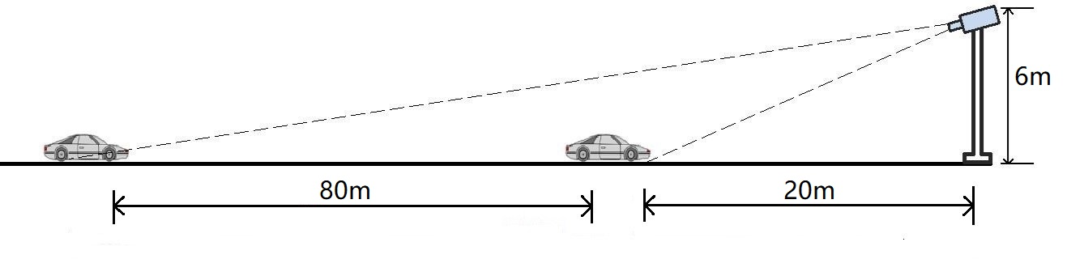
The following figure shows the actual installation scenario.
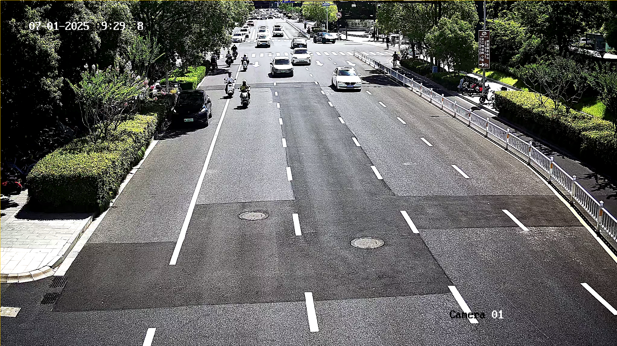

Pixel Requirement
For each event, the server's internal algorithm has a minimum value requirement, which is as follows:
Event | Algorithm Technical requirements
Stopped Vehicle | The vehicle target pixels not less than 64x64.
Driving on the Lane Line | The vehicle target pixels not less than 64x64.
Lane Change | The vehicle target pixels not less than 64x64.
Continuous Lane Change | The vehicle target pixels not less than 64x64.
Wrong-Way Driving | The vehicle target pixels not less than 64x64.
Speeding | The vehicle target pixels not less than 64x64.
Low-Speed | The vehicle target pixels not less than 64x64.
Rapid Deceleration | The vehicle target pixels not less than 64x64.
Congestion | The queue length exceeds 80 meters, the average travel speed is lower than 20 km/h, and the vehicle congestion exceeds half of the lane capacity.
Construction | The detection area is under construction, and the construction workers must have significant displacement. The short side of the target pixel should be no less than 32.
Roadblock | The short side of the roadblock's pixels must be no less than 32.
Pedestrian | The detection area contains pedestrians, and these pedestrians must have significant movement. The short side of the target pixel should be no less than 32.
Fallen Object | The short side of the object's pixels must be no less than 32.
Traffic Accident | Two vehicles collided, and someone got out of the car to check the situation. The pixel size of the vehicles was no less than 64x64, and the short side of the pedestrian's pixel was no less than 32.
Emergency Lane Occupation | The vehicle target pixels not less than 64x64.
Fire | The range of the flame occupies no less than 1/10 of the field of view.
Smoke | The smoke coverage occupies no less than 1/10 of the field of view.
Occupied by Animal | Groups of animals are positioned in the middle of the road, and individual animals are ineffective.

.

Device Activation
Purpose:
For the first use of the device, you need to activate the device by setting an admin password. No operation is allowed before activation. You can also activate the device via SADP.
Steps:
- Download SADP from the official website https://www.hikvision.com/en/.

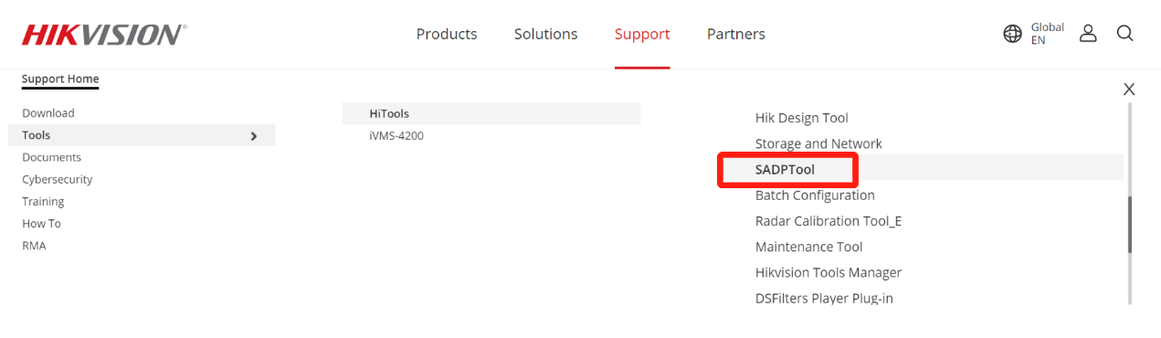
- Run the software.
SADP will automatically search all online devices in LAN. The results are displayed in sheet, with device type, IP address, security status, device serial No. and many other information, as shown in the figure below.
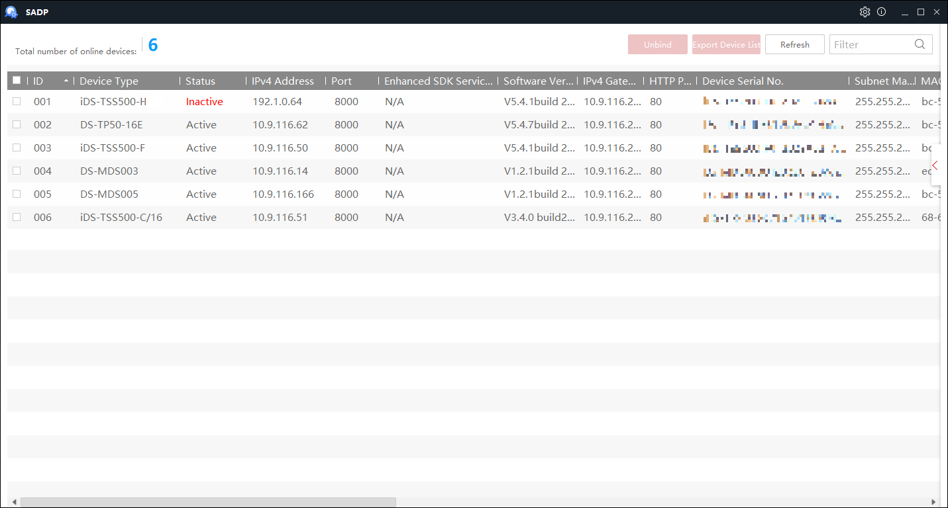
- Check the device to be activated to pop up the Activate the Device window on the right.
- Set device password in the popup window.
- Click Activate to complete activation.
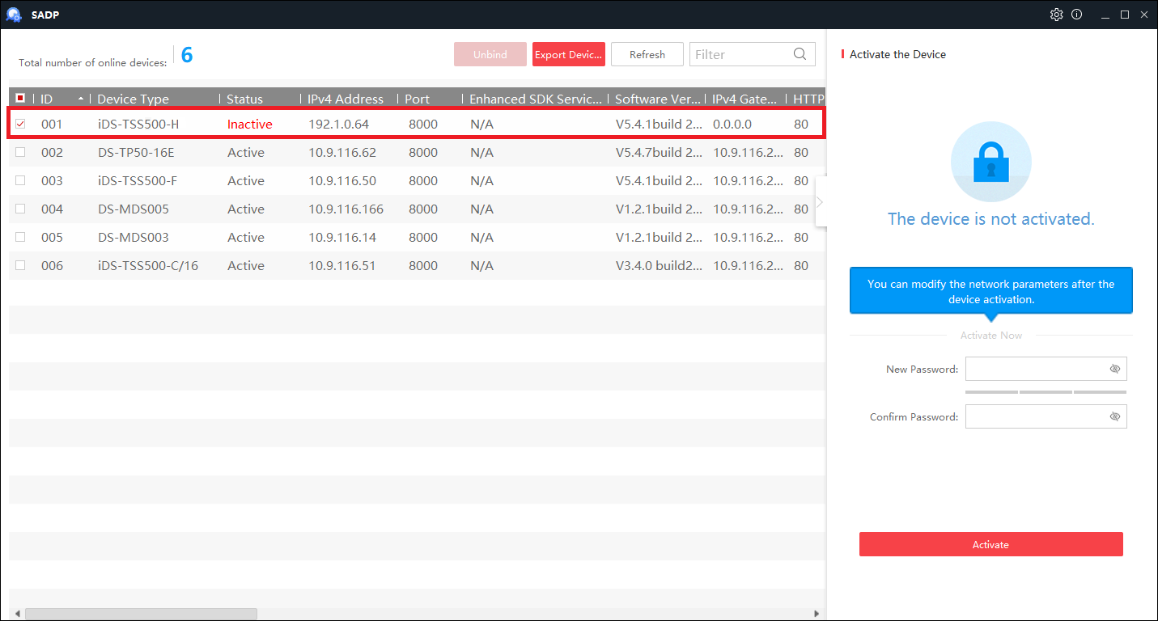
- Check the activated device to pop up the Modify Network Parameters window on the right.
- Enter device IP address, subnet mask and admin password.
- Click Modify to finish IP settings.
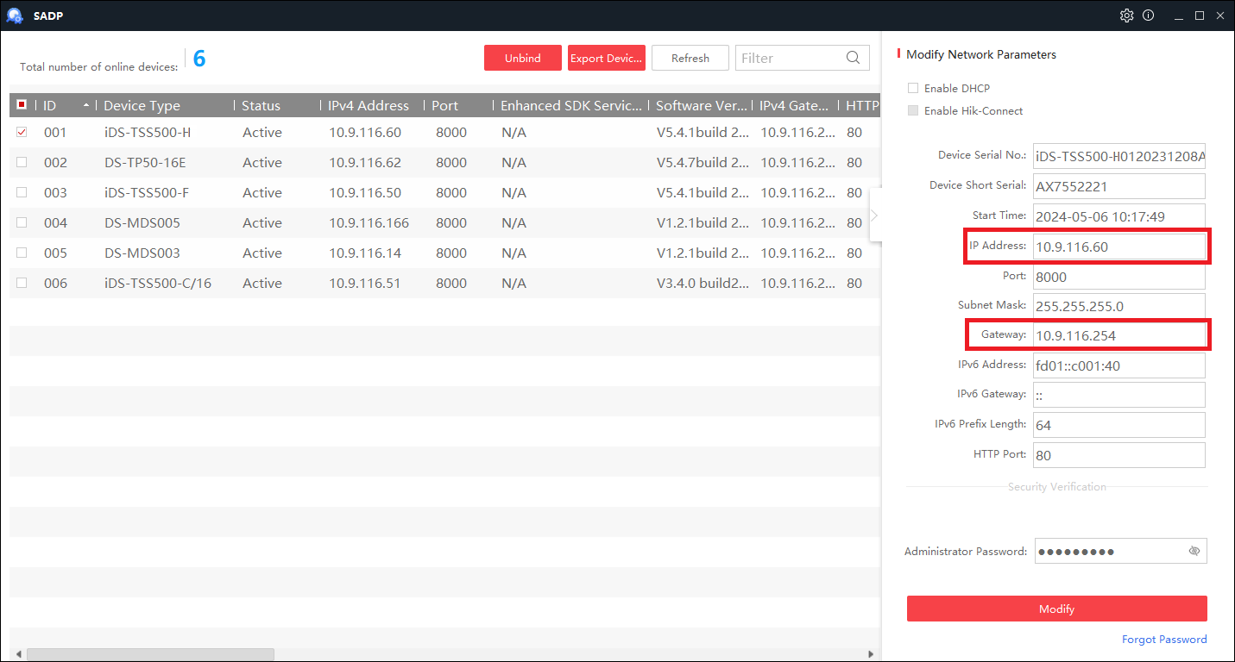
- Modify the computer IP address to be in the same network segment as the device.
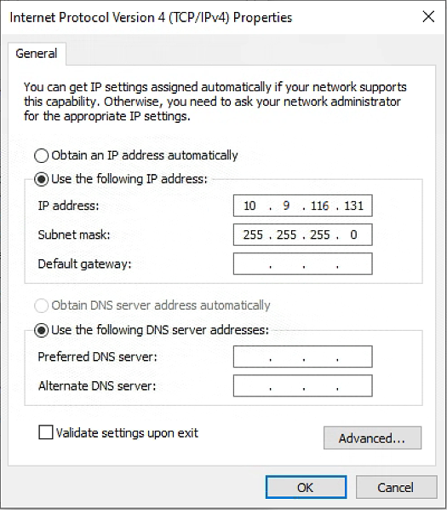
- Use the IE, Edge or Chrome browser to login the device.
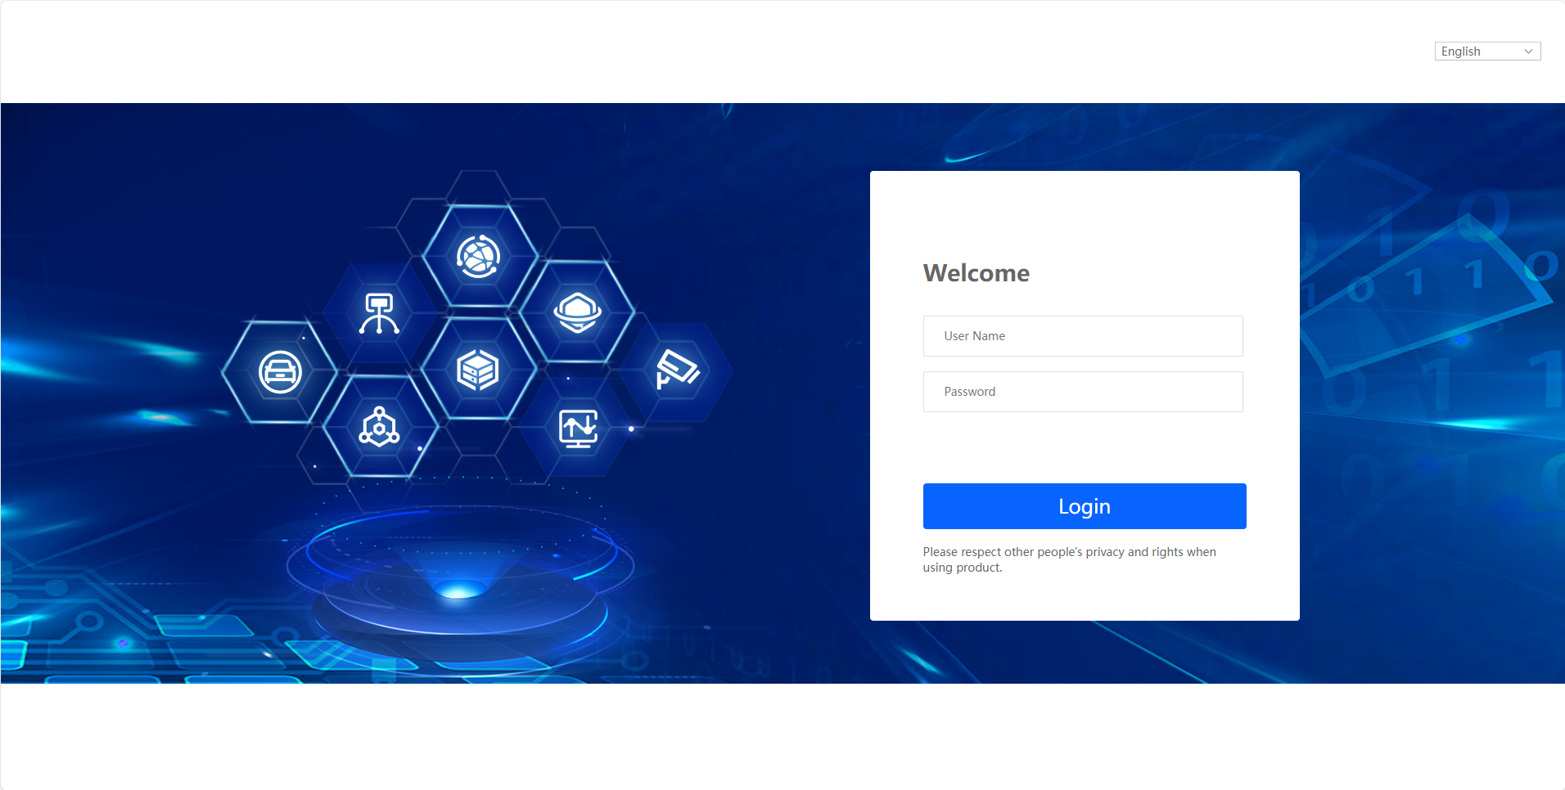

Device Configuration

Set Network
Steps:
- The device has a total of 2 network ports, namely G1 and G2. G1 corresponds to the first network card built into the device, while G2 corresponds to the second network card built into the device. The G1 port is internally connected to the 8 P ports. Usually, the G1 port is connected to the switch, while the cameras are directly connected to the P ports.
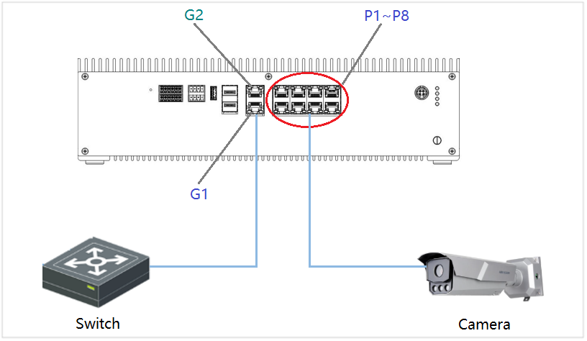
- Go to System> Network Settings > TCP/IP > Network Card 1.
- Enter information, such as IPv4 Address, IPv4 Subnet Mask and IPv4 Default Gateway.
- Click Save.
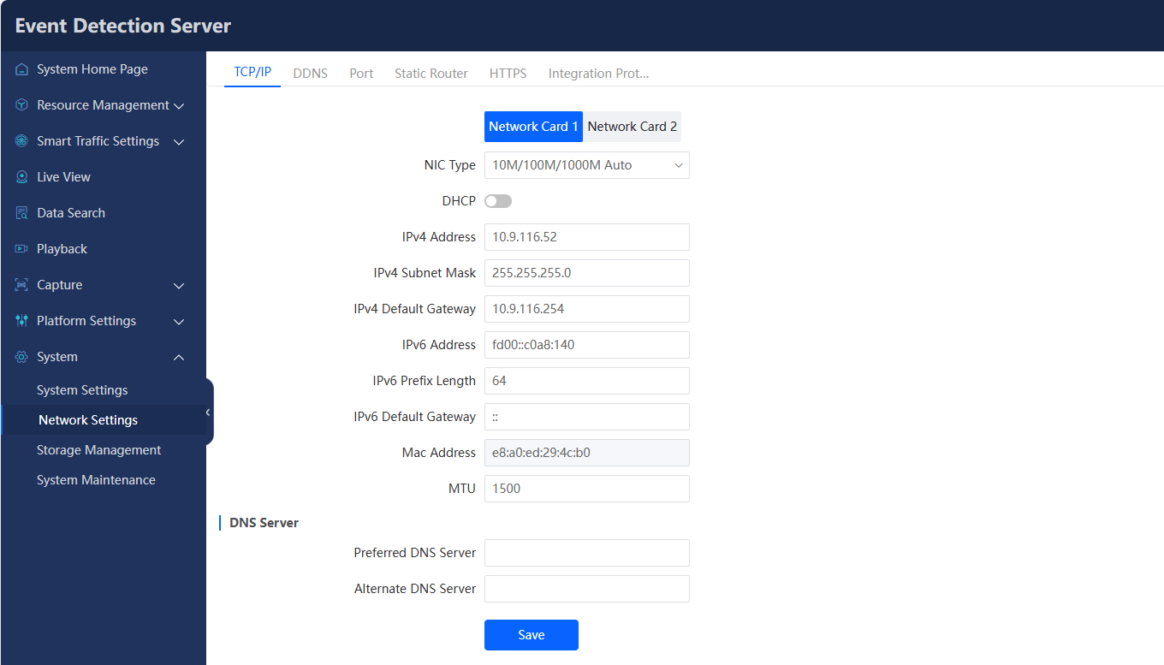

Upgrade Firmware and Restore Default Settings
Steps:
- Go to System > System Maintenance > Upgrade & Maintenance.
- Click Browse to select firmware.
- Click Upgrade to upgrade the firmware.
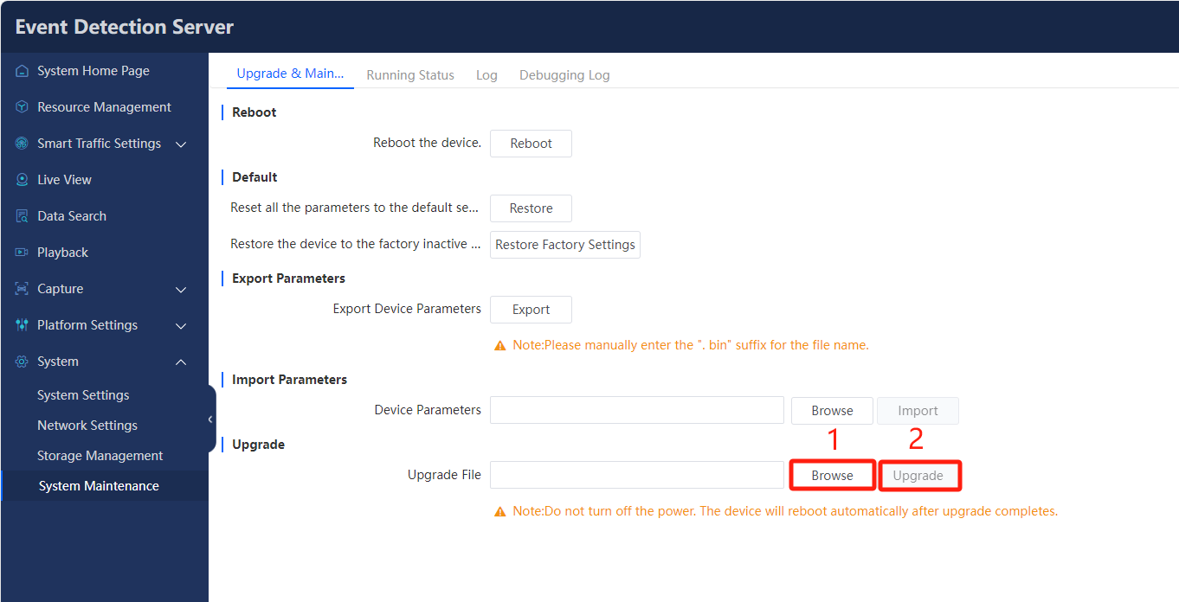
- Click Restore to restore the server.
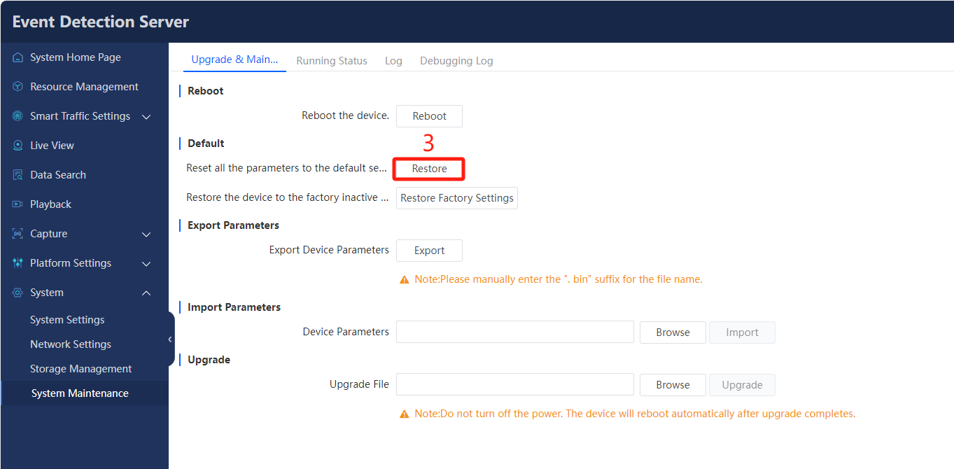

Modify Time Zone
Steps:
- Go to System > System Settings > Time Settings.
- Select Time Zone from the dropdown list.
- Select clock synchronization mode, including NTP Time Sync., Manual Time Sync., and SDK Time Sync., etc.
- Click Save.
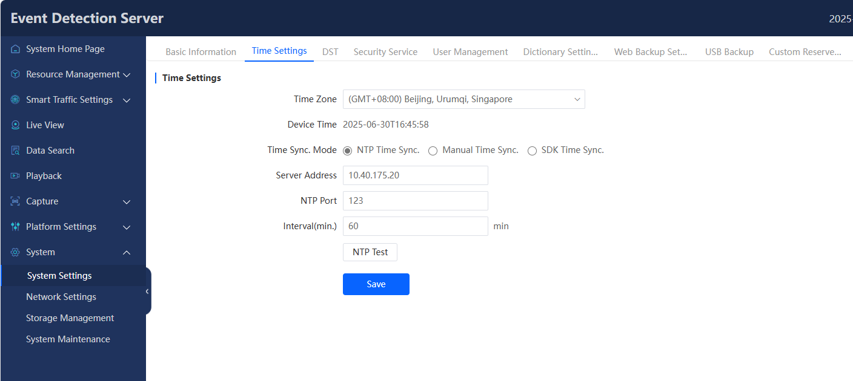

Add Cameras
Steps:
- Go to Resource Management.
- Click Add and fill in the organization name to create the organization information.
- Click OK.
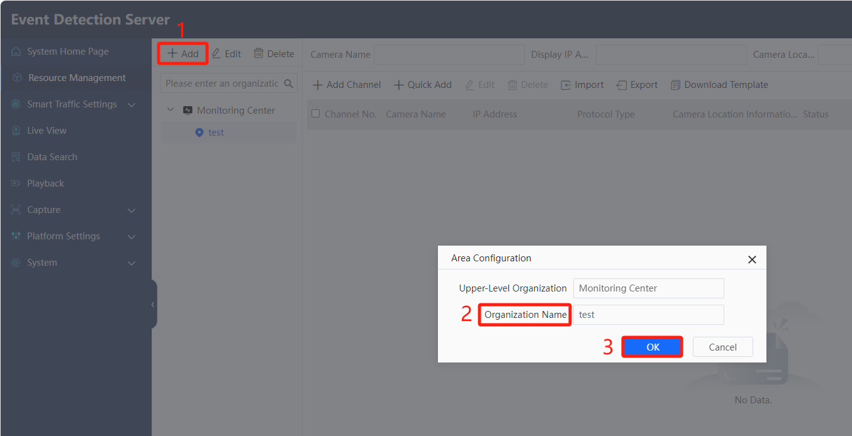
- Click Add Channel, input IP Address, User Name, Password, and Confirm the password.
- Click OK.
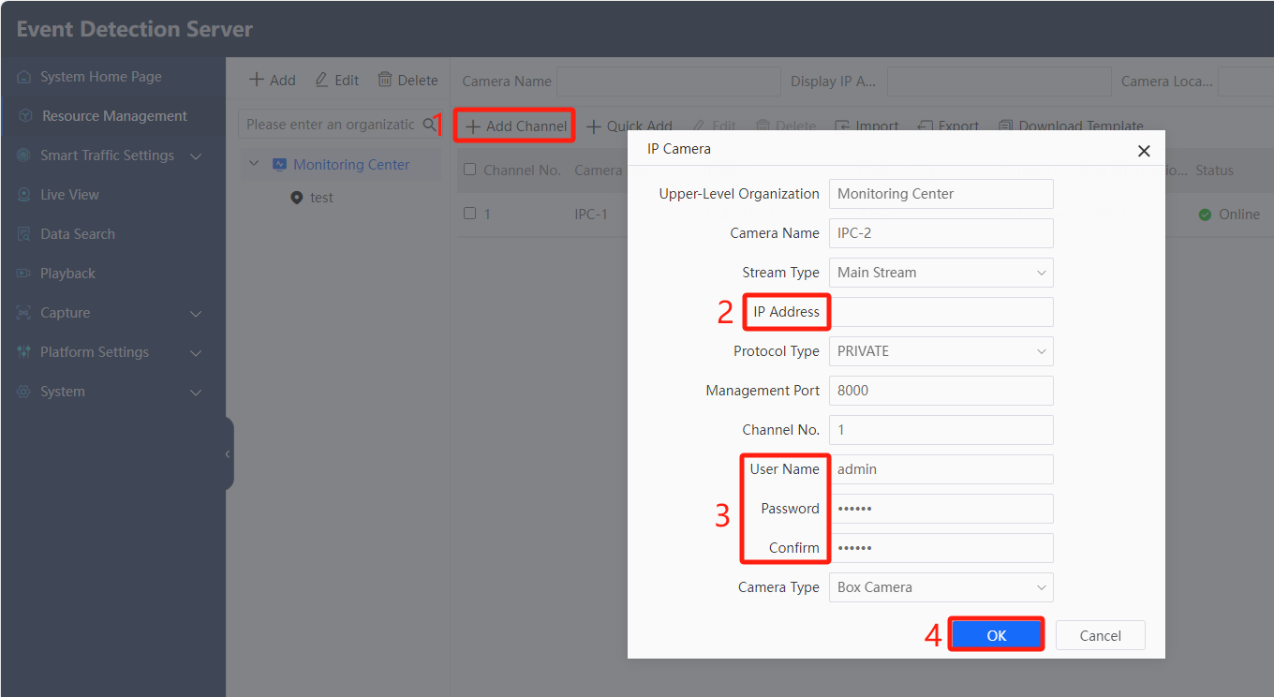
- Or you can use a quick add method. Click Quick Add, the online network cameras will be displayed in a sheet.
- Check the camera to be added, and input User Name and Password of the camera.
- Click OK.
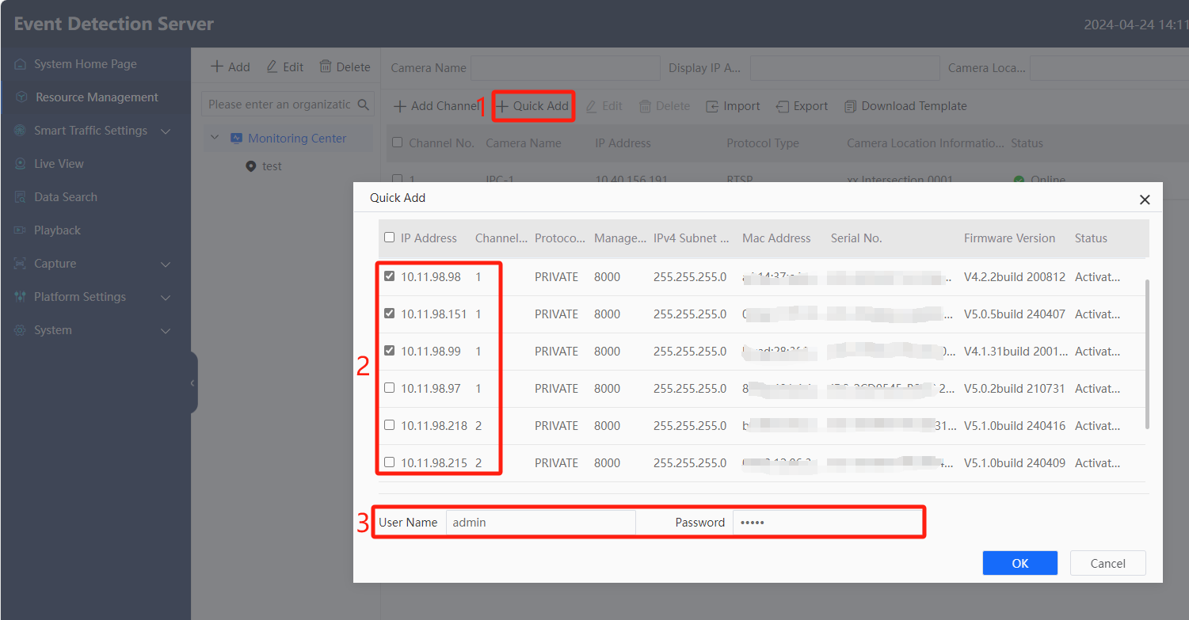
Note:
- The front-end camera should not exceed 4MP. If it is larger than 4MP, the device can only record videos and will not perform incident detection.

Configure License Parameters
Steps:
- Go to Capture > Capture Parameters > License Parameters.
- Select Country/Region from the dropdown list.
- Click OK.
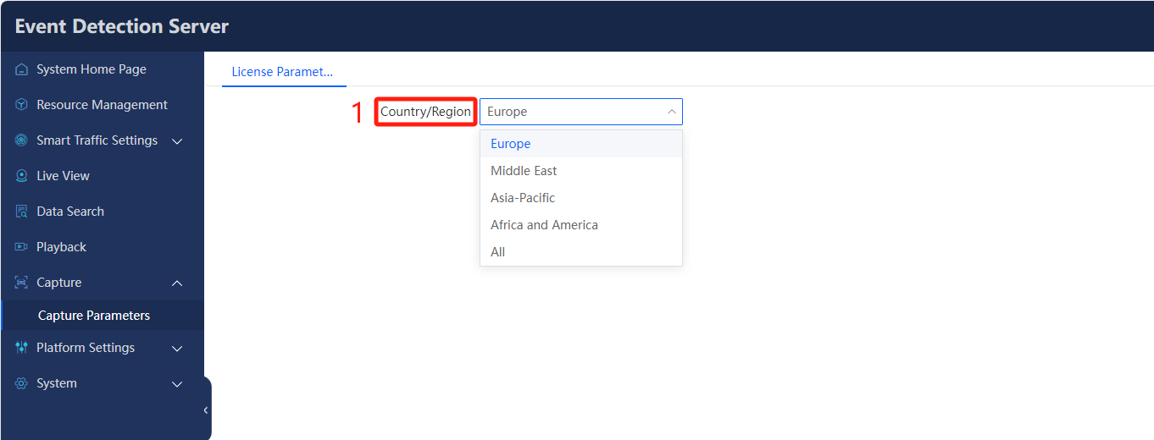

Configure Text Overlay
Steps:
- Go to Smart Traffic Settings > Parameter Configuration > Text Overlay.
- Click Enable Overlay Information.
- Click Overlay Content, and check the Lane No., Capture Time, License Plate NO., etc., and these information will overlay on the captured picture.
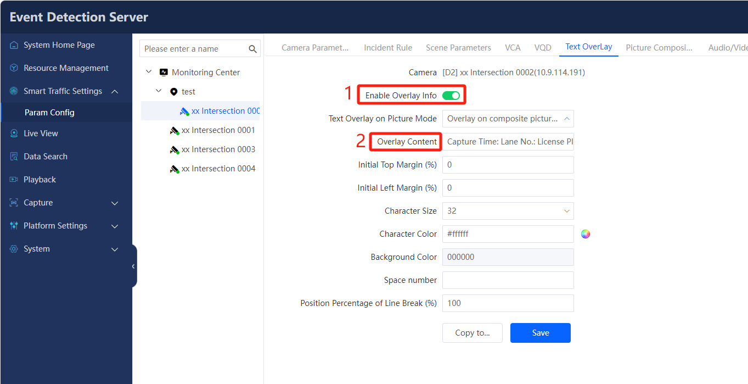
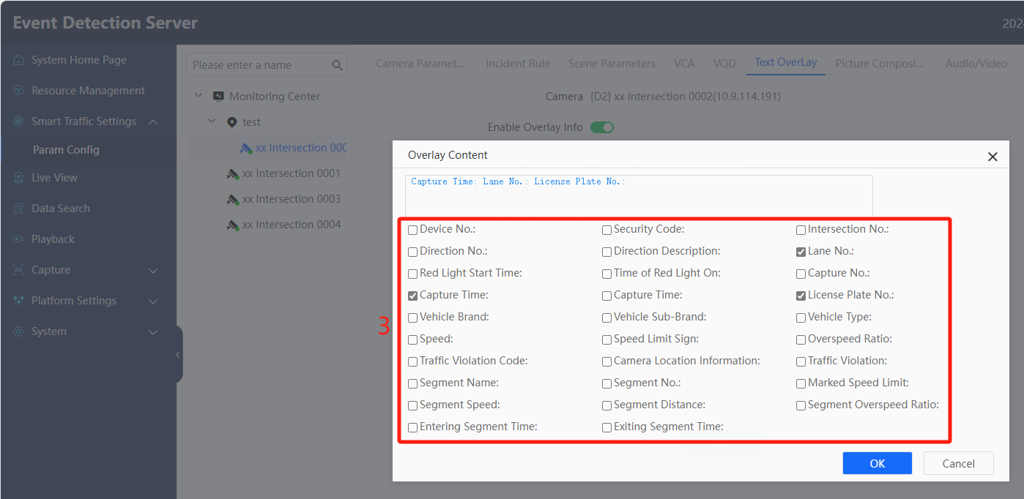
- Set the Character Size, Character Color.
- Click Save.
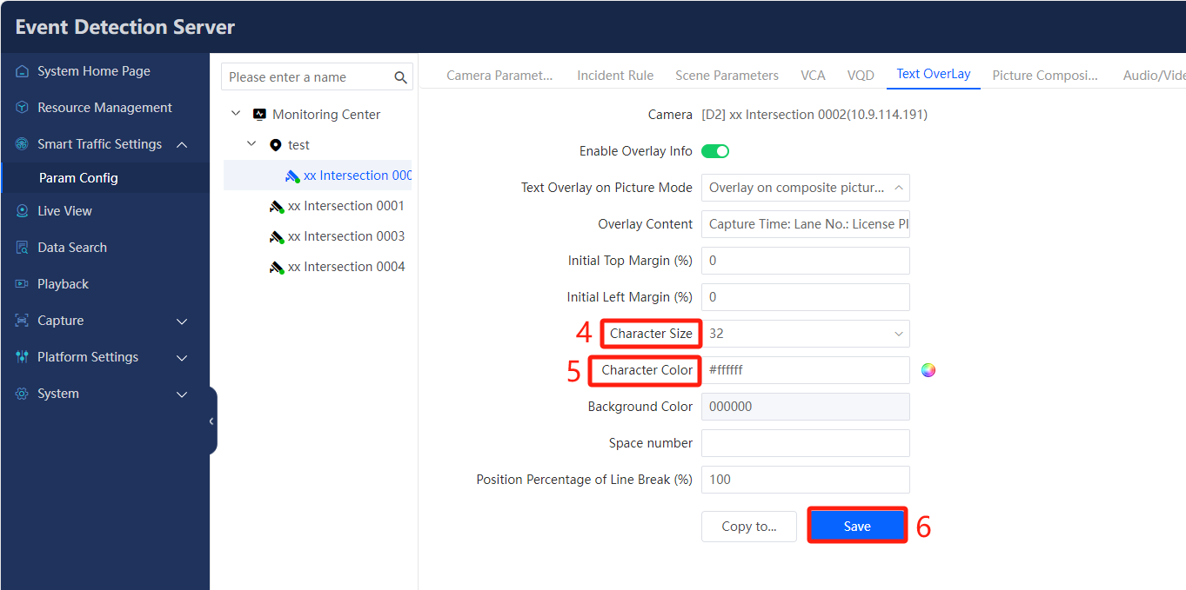

Configure Video Record
Steps：
- Go to System > Storage Management > Record Configuration.
- Select the camera and enable the video recording.
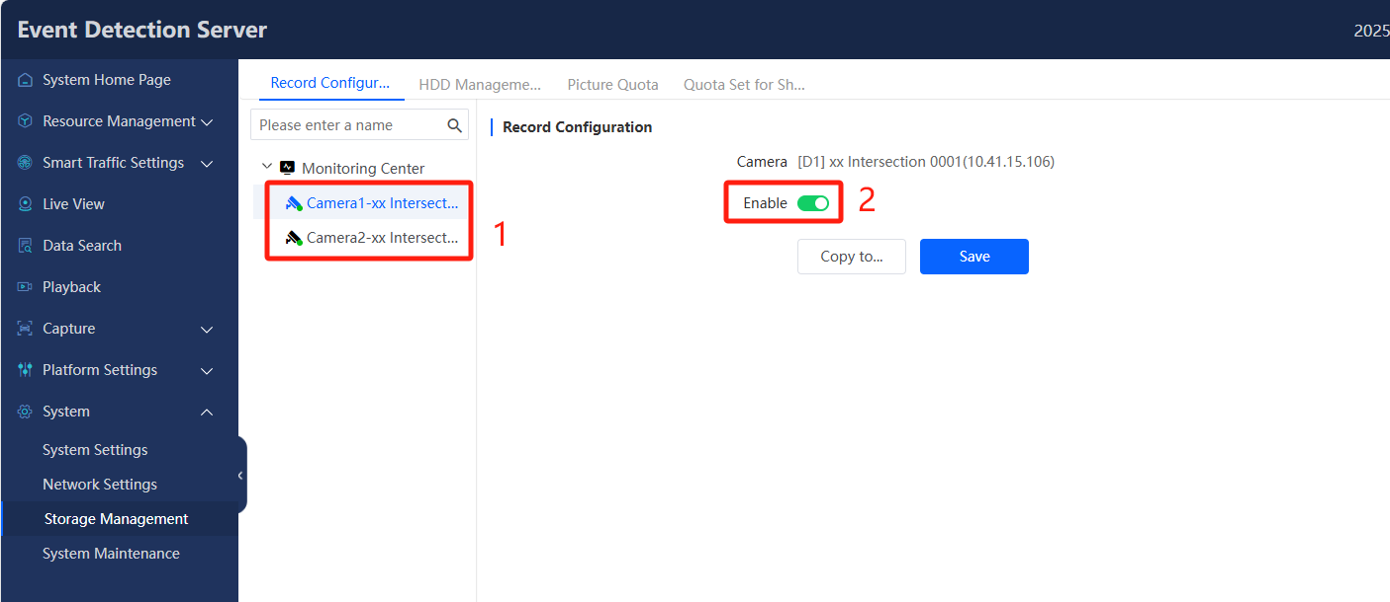

Draw Area and Line
Steps：
- Go to Smart Traffic Settings > Parameter Configuration > Incident Rule> Draw Area.
- Draw Lane Lines, Detection Areas, and Flow Trigger Lines. The device supports a maximum 6 lanes configuration, each lane is determined by two lane lines (Left & Right). The detection area should cover the entire lane. The Flow Trigger Line 1 is located at 1/3 of the top down of the screen, and the Flow Trigger Line 2 is located at 2/3 of the top down of the screen.
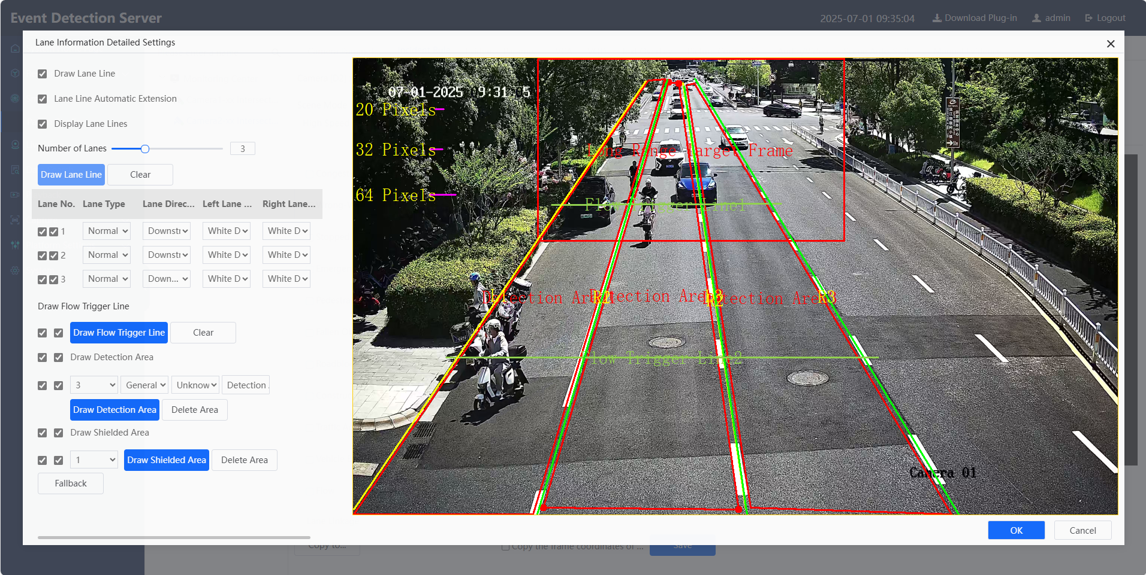
Note:
  - When drawing lane lines, it should be noted that different lanes should not cross, that is, the R1 must be on the left of L2.
  - Lane lines should avoid areas easily trigger false detection, such as character stacking areas and road markers.
  - The lane line vertex cannot contact with the screen boundary line.
  - The length of lane line should not be too long (except for congestion detection) to ensure that the events occurring in the lane meet the requirements of pixel points. If the lane line is too long, it will not only fail to improve the capture rate, but also increase the number of false positives.
  - If it is necessary to detect congestion events in the lane, it is not recommended to turn on the parking and reverse functions in the current lane, otherwise there will be a large number of false positives.
  - Drag the Long Range Target Frame at the top of the screen, when the vehicle with violation event is far away from the lens, the target frame will appear on the live view image to mark the vehicle position.
- Set the Lane Type, Lane Direction, Left Lane Line Type, Right Lane Line Type, these parameters must be consistent with the real situation.
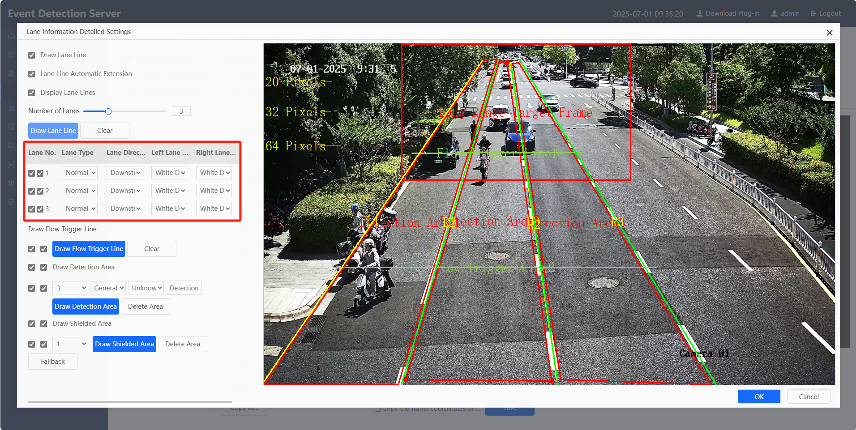
- Click OK.
- If you want to enable the traffic statistics function, you need to check Flow, then set the Report Time, and set the Flow distance, it must be the actual distance between two Flow Trigger Lines, which is used to calculate the average speed of the vehicle.
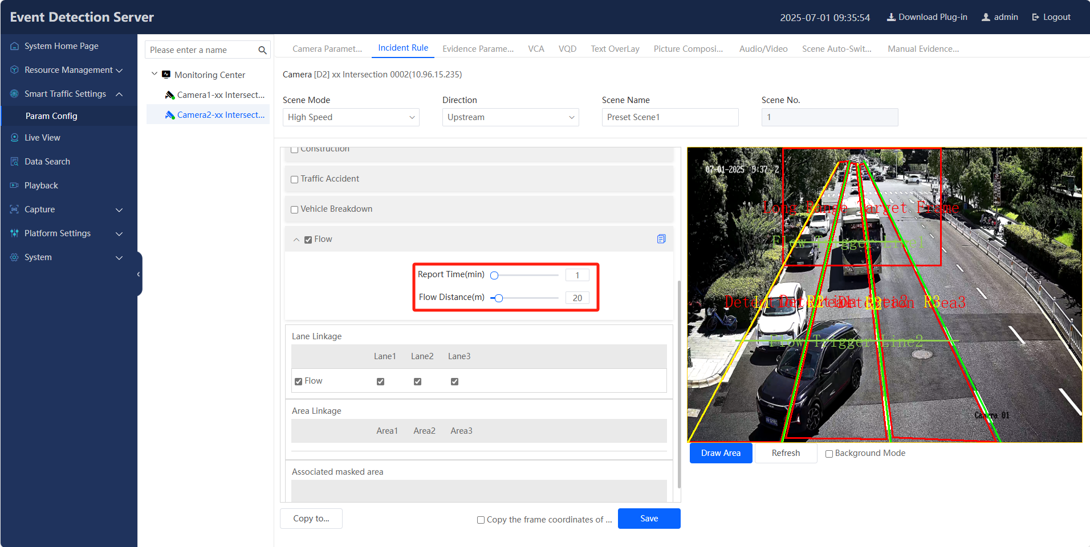
- Click Save.

Configure Incident Rule
Steps:
- Go to Smart Traffic Settings > Parameter Configuration > Incident Rule.
- Select the Scene Mode from the drop-down list. Different modes support different incident types and use different detection algorithms.
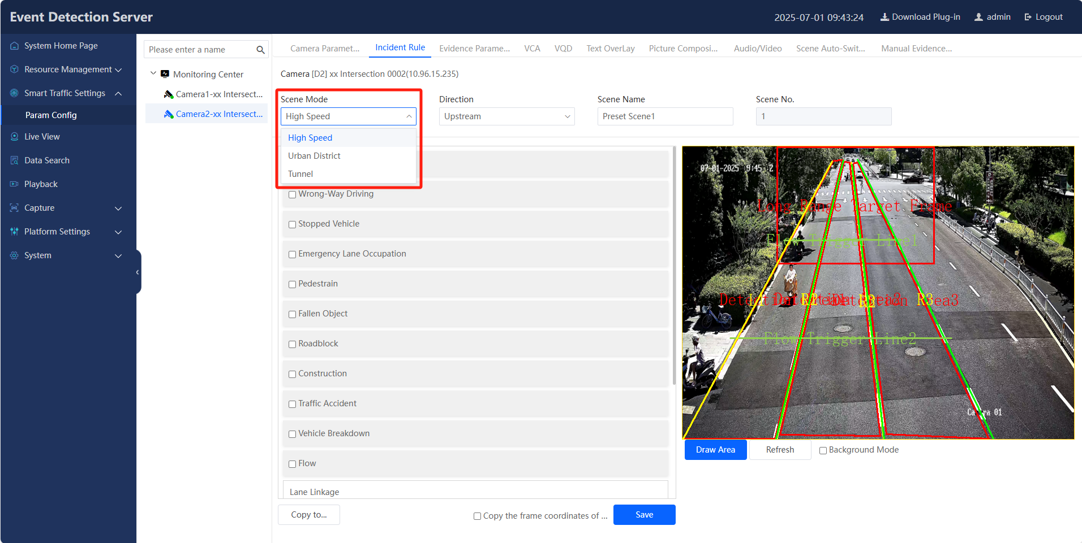
- Check the Incident rule according to the customer's needs, such as Stopped Vehicle, Wrong-Way Driving, Driving on the Lane Line, Lane Change, etc.
- Click Save.
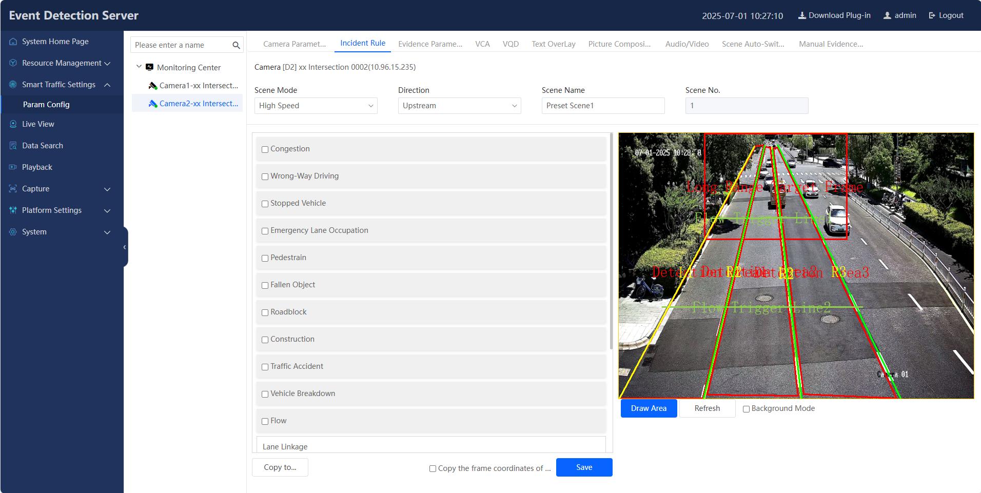
Note:
- Congestion: The logic of the internal algorithm is that the queue length of the traffic flow is greater than 80m, and the average speed is less than 20km/h, which should be met at the same time during the test.
- Construction: The event can only be detected when there are more than two pedestrians and roadblocks in the scene at the same time.
- Roadblock: Common roadblocks include reflective cones and reflective buckets, which are recommended for testing.
- Driving on lane line and illegal lane change: These two events have high requirements for setting up the environment, so it is not recommended to enable these two events in the tilted scene.
- Pedestrian: Person must be within the detection area and have obvious displacement. The short side pixel should not be less than 32, and it should not be detected at night.
- Fallen Object: The target must appear in the detection area from nothing and remain there for more than 10 seconds without moving. The short side pixel should be no less than 32, and it should not be detected at night.
- Take the Stopped Vehicle as an example, set the Duration, Filtering Time, The Degree Of Congestion, Capture Sensitivity, and then check the linked area.
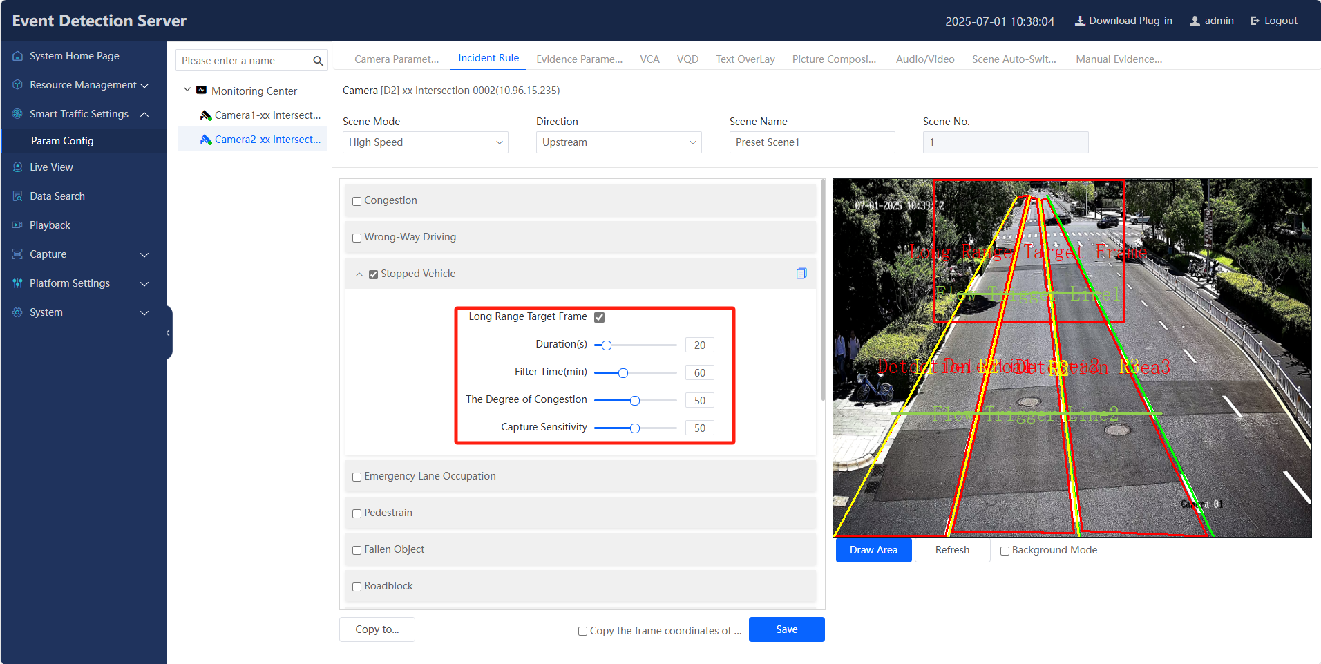
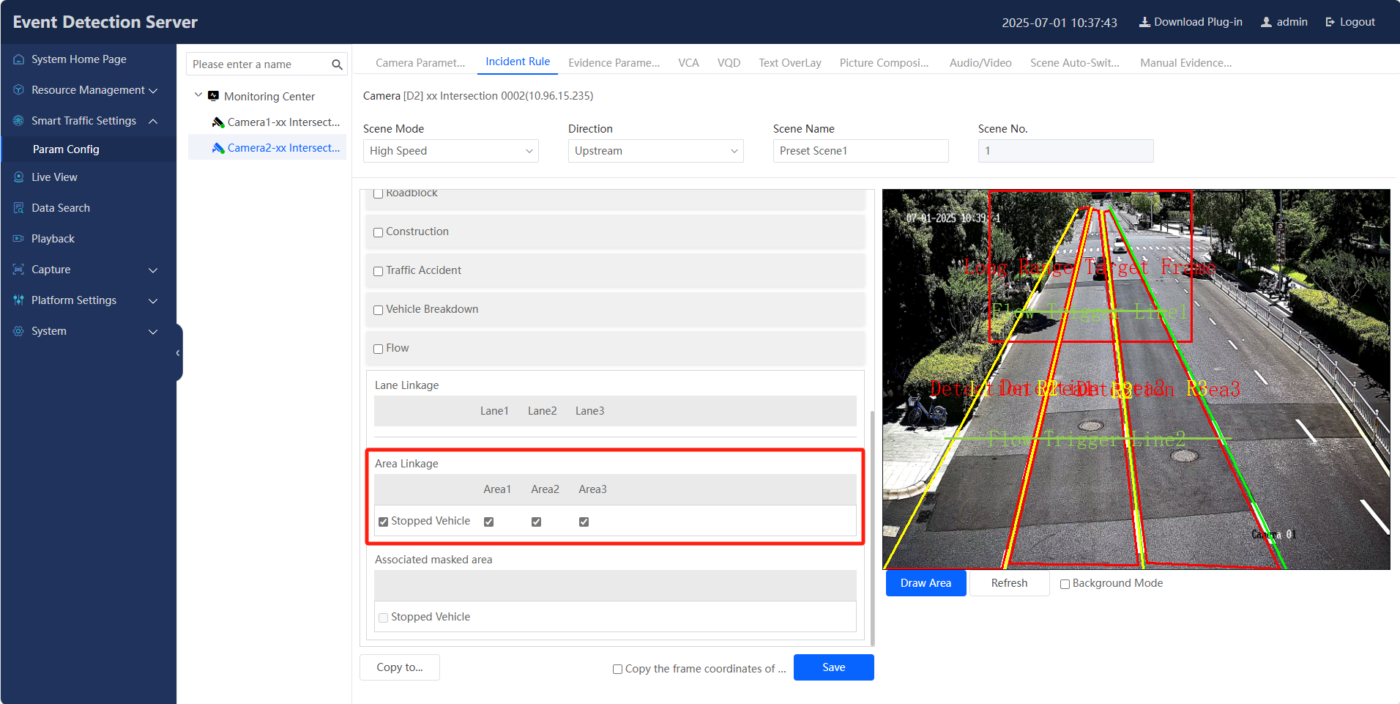
Note:
- Duration(s): When the stopped vehicle time occurs beyond this setting value, the camera is triggered to capture pictures.
- Filter Time(min): After the stopped vehicle is captured, the same vehicle will not be captured within the same position setting time.
- The Degree of Congestion: When the congestion exceeds the configured value, the camera stops capturing.
- Capture Sensitivity: Sensitivity equal to or less than 30, filter non-displacement target capture.

Data Search
Steps:
- Go to Data Search > Traffic Data Search.
- Specify search condition, click Search to search traffic data.
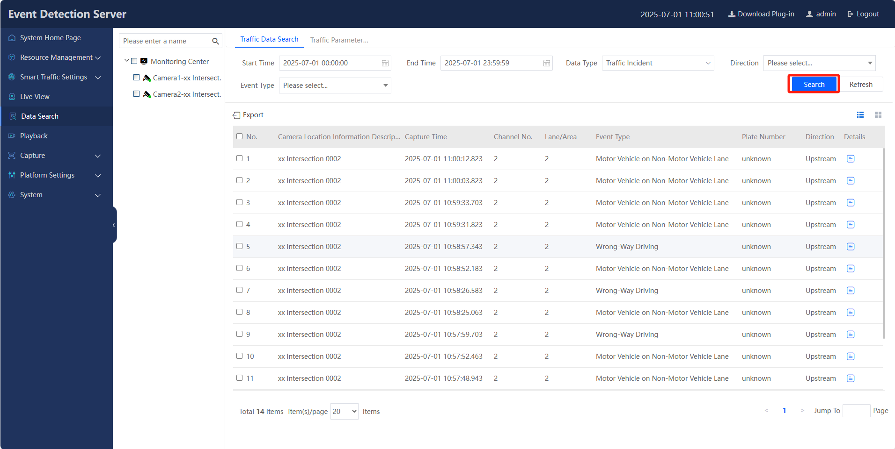

Data Display
Steps:
- Go to System Home Page, all the captured data is visualized on this page, such as the number of certain incidents, the total number of incidents on a given day, etc.
